*Florida International University*

*School of Computing and Information Sciences*

Software Engineering Focus

Feature Document

User Story ID: #741 Continue To Implement – A Machine Learning Algorithm from Resulting Data

**Name:** Filip Klepsa

**Team Member(s):** Lukas Borges, Cristian Cabrera, Hamilton Chevez, Nicolette Celli, Francisco Lozada

**Project:** AR-VR-VE for Computer Science (Multimodal Interaction with ASL use case)

**Product Owner(s)**: Francisco Ortega

**Mentor(s)**: Francisco Ortega

**Instructor**: Francisco Ortega, Masoud Sadjadi

**User Story Name: 741 Continue To Implement – A Machine Learning Algorithm from Resulting Data**

Description:

* As a developer, I want to continue to work on the Nearest Neighbor approach MLA selected from the data from user story [#727](https://fiu-scis-seniorproject.mingle.thoughtworks.com/projects/ar_vr_ve_for_computer_science_/cards/727) to continue to implement the real-time gesture recognition feature.

Acceptance Criteria:

* Design the architecture that will pass recorded vector data to the MLA subsystem for processing.
* Get the program to perform some interpretation in real-time.

**Use Case**: **Gesture Recognition**

**Participating Actor:**

* User

**Entry Condition:**

* Actor must have application running and Leap Motion controller plugged in.
* Actor must have recorded gestures and trained the application.
* Actor must be on interpreter form.
* Actor must have hit interpret button.

**Exit Condition:**

* The capture is completed.
* The actor is notified that the capture has completed and is given the option to recapture a new gesture to interpret.
* The detected gesture is displayed.
* The Hit-Rate is displayed.

|  |  |
| --- | --- |
| **Actor Steps** | **System Steps** |
| 1. The actor moves their hand in front of the Leap Motion Device Field of View, performs a gesture, and hits interpret. |  |
|  | 2. The system activates the Leap Motion Device and begins to poll vector data. |
|  | 3. The system captures the physical gestures. |
|  | 4. The system compares vector data between the captured and all recorded frames in the program library, then outputs hit-rate of all tested gestures. |
|  | 5. The system outputs the gesture name to the “gesture detected” label |
| 6. The actor can choose to recapture a new gesture frame for interpretation. |  |

**Use Case Diagram**

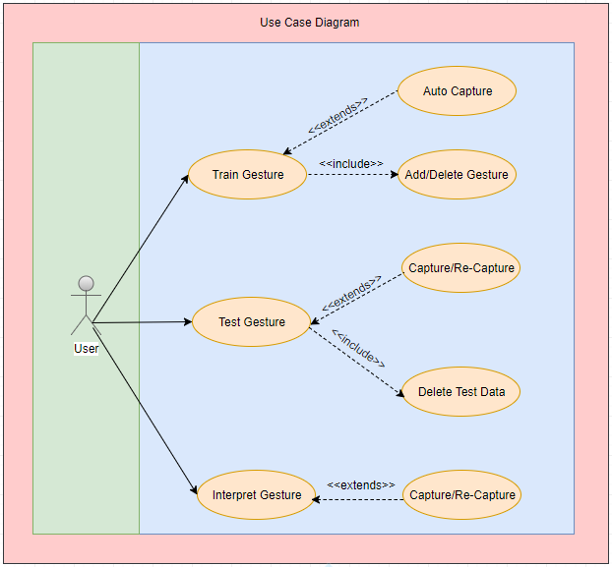

**Sequence Diagram**

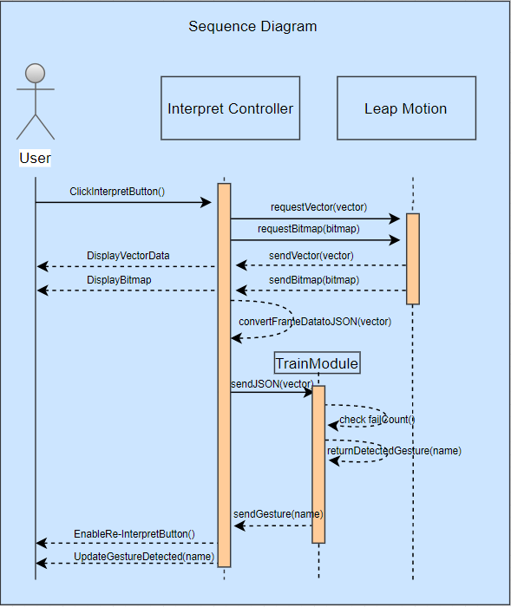

**Class Diagram**

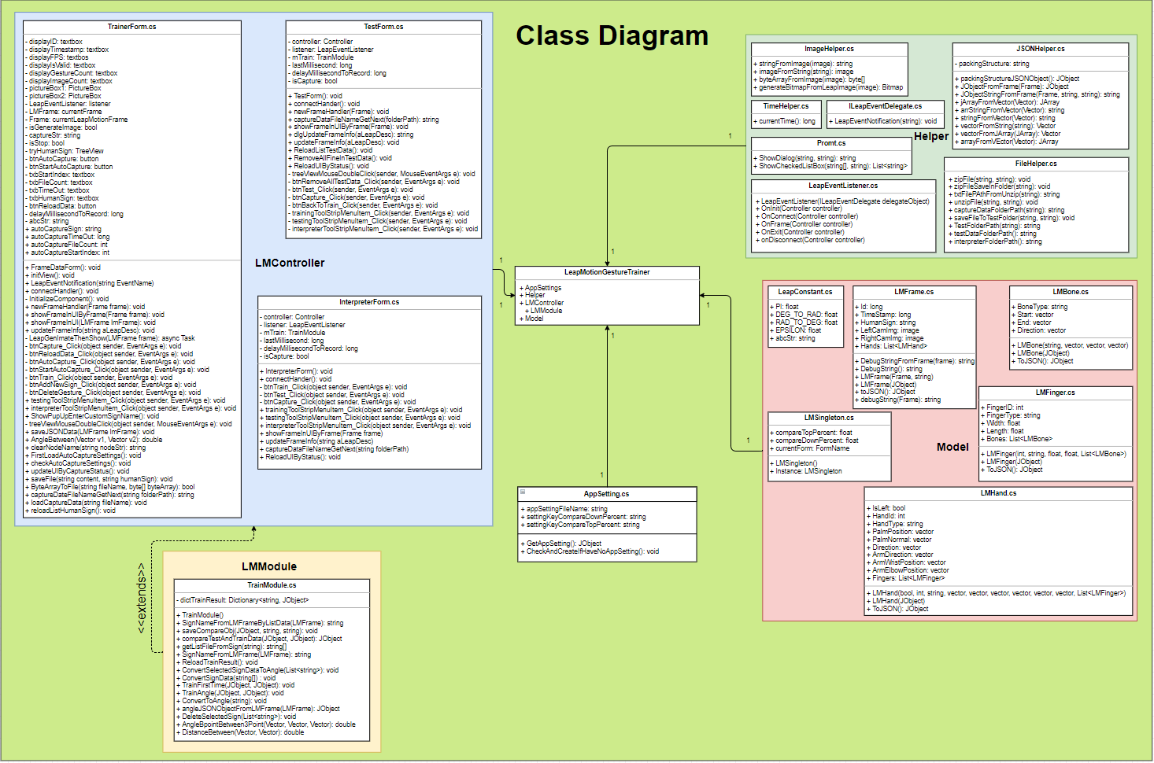

**Unit Test**

|  |  |  |  |  |  |
| --- | --- | --- | --- | --- | --- |
| Test case ID | Testcase name | Description | Procedure | Expected Result | Test result |
| TC_01 | Interpreter with Sign A | Check interpreter function for gesture Sign A | 1. Open App  2. Connect with device  3. Create gesture Sign A and click TRAIN button  4. Click menu and choose Interpreter  5. Perform the gesture  6. Click Interpret button | 1. Show capture and debug console on right screen  2. Show result (Detected Sign: A) and rate lowest fail counts in other signs (see the right corner screen) | Pass |
| TC_02 | Interpreter with Sign B | Check interpreter function for gesture Sign B | 1. Open App  2. Connect with device  3. Create gesture Sign B and click TRAIN button  4. Click menu and choose Interpreter  5. Perform the gesture  6. Click Interpret button | 1. Show capture and debug console on right screen  2. Show result (Detected Sign: B) and rate lowest fail counts in other signs (see the right corner screen) | Pass |
| TC_03 | Interpreter with Sign C | Check interpreter function for gesture Sign C | 1. Open App  2. Connect with device  3. Create gesture Sign C and click TRAIN button  4. Click menu and choose Interpreter  5. Perform the gesture  6. Click Interpret button | 1. Show capture and debug console on right screen  2. Show result (Detected Sign: C) and rate lowest fail counts in other signs (see the right corner screen) | Pass |
| TC_04 | Interpreter with Sign D | Check interpreter function for gesture Sign D | 1. Open App  2. Connect with device  3. Create gesture Sign D and click TRAIN button  4. Click menu and choose Interpreter  5. Perform the gesture  6. Click Interpret button | 1. Show capture and debug console on right screen  2. Show result (Detected Sign: D) and rate lowest fail counts in other signs (see the right corner screen) | Pass |
| TC_05 | Interpreter with Sign E | Check interpreter function for gesture Sign E | 1. Open App  2. Connect with device  3. Create gesture Sign E and click TRAIN button  4. Click menu and choose Interpreter  5. Perform the gesture  6. Click Interpret button | 1. Show capture and debug console on right screen  2. Show result (Detected Sign: E) and rate lowest fail counts in other signs (see the right corner screen) | Pass |
| TC_06 | Interpreter with Sign F | Check interpreter function for gesture Sign F | 1. Open App  2. Connect with device  3. Create gesture Sign F and click TRAIN button  4. Click menu and choose Interpreter  5. Perform the gesture  6. Click Interpret button | 1. Show capture and debug console on right screen  2. Show result (Detected Sign: F) and rate lowest fail counts in other signs (see the right corner screen) | Pass |
| TC_07 | Interpreter with Sign G | Check interpreter function for gesture Sign G | 1. Open App  2. Connect with device  3. Create gesture Sign G and click TRAIN button  4. Click menu and choose Interpreter  5. Perform the gesture  6. Click Interpret button | 1. Show capture and debug console on right screen  2. Show result (Detected Sign: G) and rate lowest fail counts in other signs (see the right corner screen) | Pass |
| TC_08 | Interpreter with Sign H | Check interpreter function for gesture Sign H | 1. Open App  2. Connect with device  3. Create gesture Sign H and click TRAIN button  4. Click menu and choose Interpreter  5. Perform the gesture  6. Click Interpret button | 1. Show capture and debug console on right screen  2. Show result (Detected Sign: H) and rate lowest fail counts in other signs (see the right corner screen) | Pass |
| TC_09 | Interpreter with Sign I | Check interpreter function for gesture Sign I | 1. Open App  2. Connect with device  3. Create gesture Sign I and click TRAIN button  4. Click menu and choose Interpreter  5. Perform the gesture  6. Click Interpret button | 1. Show capture and debug console on right screen  2. Show result (Detected Sign: I) and rate lowest fail counts in other signs (see the right corner screen) | Pass |
| TC_10 | Interpreter with Sign J | Check interpreter function for gesture Sign J | 1. Open App  2. Connect with device  3. Create gesture Sign J and click TRAIN button  4. Click menu and choose Interpreter  5. Perform the gesture  6. Click Interpret button | 1. Show capture and debug console on right screen  2. Show result (Detected Sign: J) and rate lowest fail counts in other signs (see the right corner screen) | Pass |
| TC_11 | Interpreter with Sign K | Check interpreter function for gesture Sign K | 1. Open App  2. Connect with device  3. Create gesture Sign K and click TRAIN button  4. Click menu and choose Interpreter  5. Perform the gesture  6. Click Interpret button | 1. Show capture and debug console on right screen  2. Show result (Detected Sign: K) and rate lowest fail counts in other signs (see the right corner screen) | Pass |
| TC_12 | Interpreter with Sign L | Check interpreter function for gesture Sign L | 1. Open App  2. Connect with device  3. Create gesture Sign L and click TRAIN button  4. Click menu and choose Interpreter  5. Perform the gesture  6. Click Interpret button | 1. Show capture and debug console on right screen  2. Show result (Detected Sign: L) and rate lowest fail counts in other signs (see the right corner screen) | Pass |
| TC_13 | Interpreter with Sign M | Check interpreter function for gesture Sign M | 1. Open App  2. Connect with device  3. Create gesture Sign M and click TRAIN button  4. Click menu and choose Interpreter  5. Perform the gesture  6. Click Interpret button | 1. Show capture and debug console on right screen  2. Show result (Detected Sign: M) and rate lowest fail counts in other signs (see the right corner screen) | Pass |
| TC_14 | Interpreter with Sign N | Check interpreter function for gesture Sign N | 1. Open App  2. Connect with device  3. Create gesture Sign N and click TRAIN button  4. Click menu and choose Interpreter  5. Perform the gesture  6. Click Interpret button | 1. Show capture and debug console on right screen  2. Show result (Detected Sign: N) and rate lowest fail counts in other signs (see the right corner screen) | Pass |
| TC_15 | Interpreter with Sign O | Check interpreter function for gesture Sign O | 1. Open App  2. Connect with device  3. Create gesture Sign O and click TRAIN button  4. Click menu and choose Interpreter  5. Perform the gesture  6. Click Interpret button | 1. Show capture and debug console on right screen  2. Show result (Detected Sign: O) and rate lowest fail counts in other signs (see the right corner screen) | Pass |
| TC_16 | Interpreter with Sign P | Check interpreter function for gesture Sign P | 1. Open App  2. Connect with device  3. Create gesture Sign P and click TRAIN button  4. Click menu and choose Interpreter  5. Perform the gesture  6. Click Interpret button | 1. Show capture and debug console on right screen  2. Show result (Detected Sign: P) and rate lowest fail counts in other signs (see the right corner screen) | Pass |
| TC_17 | Interpreter with Sign Q | Check interpreter function for gesture Sign Q | 1. Open App  2. Connect with device  3. Create gesture Sign Q and click TRAIN button  4. Click menu and choose Interpreter  5. Perform the gesture  6. Click Interpret button | 1. Show capture and debug console on right screen  2. Show result (Detected Sign: Q) and rate lowest fail counts in other signs (see the right corner screen) | Pass |
| TC_18 | Interpreter with Sign R | Check interpreter function for gesture Sign R | 1. Open App  2. Connect with device  3. Create gesture Sign R and click TRAIN button  4. Click menu and choose Interpreter  5. Perform the gesture  6. Click Interpret button | 1. Show capture and debug console on right screen  2. Show result (Detected Sign: R) and rate lowest fail counts in other signs (see the right corner screen) | Pass |
| TC_19 | Interpreter with Sign S | Check interpreter function for gesture Sign S | 1. Open App  2. Connect with device  3. Create gesture Sign S and click TRAIN button  4. Click menu and choose Interpreter  5. Perform the gesture  6. Click Interpret button | 1. Show capture and debug console on right screen  2. Show result (Detected Sign: S) and rate lowest fail counts in other signs (see the right corner screen) | Pass |
| TC_20 | Interpreter with Sign T | Check interpreter function for gesture Sign T | 1. Open App  2. Connect with device  3. Create gesture Sign T and click TRAIN button  4. Click menu and choose Interpreter  5. Perform the gesture  6. Click Interpret button | 1. Show capture and debug console on right screen  2. Show result (Detected Sign: T) and rate lowest fail counts in other signs (see the right corner screen) | Pass |
| TC_21 | Interpreter with Sign U | Check interpreter function for gesture Sign U | 1. Open App  2. Connect with device  3. Create gesture Sign U and click TRAIN button  4. Click menu and choose Interpreter  5. Perform the gesture  6. Click Interpret button | 1. Show capture and debug console on right screen  2. Show result (Detected Sign: U) and rate lowest fail counts in other signs (see the right corner screen) | Pass |
| TC_22 | Interpreter with Sign V | Check interpreter function for gesture Sign V | 1. Open App  2. Connect with device  3. Create gesture Sign V and click TRAIN button  4. Click menu and choose Interpreter  5. Perform the gesture  6. Click Interpret button | 1. Show capture and debug console on right screen  2. Show result (Detected Sign: V) and rate lowest fail counts in other signs (see the right corner screen) | Pass |
| TC_23 | Interpreter with Sign W | Check interpreter function for gesture Sign W | 1. Open App  2. Connect with device  3. Create gesture Sign W and click TRAIN button  4. Click menu and choose Interpreter  5. Perform the gesture  6. Click Interpret button | 1. Show capture and debug console on right screen  2. Show result (Detected Sign: W) and rate lowest fail counts in other signs (see the right corner screen) | Pass |
| TC_24 | Interpreter with Sign X | Check interpreter function for gesture Sign X | 1. Open App  2. Connect with device  3. Create gesture Sign X and click TRAIN button  4. Click menu and choose Interpreter  5. Perform the gesture  6. Click Interpret button | 1. Show capture and debug console on right screen  2. Show result (Detected Sign: X) and rate lowest fail counts in other signs (see the right corner screen) | Pass |
| TC_25 | Interpreter with Sign Y | Check interpreter function for gesture Sign Y | 1. Open App  2. Connect with device  3. Create gesture Sign Y and click TRAIN button  4. Click menu and choose Interpreter  5. Perform the gesture  6. Click Interpret button | 1. Show capture and debug console on right screen  2. Show result (Detected Sign: Y) and rate lowest fail counts in other signs (see the right corner screen) | Pass |
| TC_26 | Interpreter with Sign Z | Check interpreter function for gesture Sign Z | 1. Open App  2. Connect with device  3. Create gesture Sign Z and click TRAIN button  4. Click menu and choose Interpreter  5. Perform the gesture  6. Click Interpret button | 1. Show capture and debug console on right screen  2. Show result (Detected Sign: Z) and rate lowest fail counts in other signs (see the right corner screen) | Pass |

**Visual User Guide**

